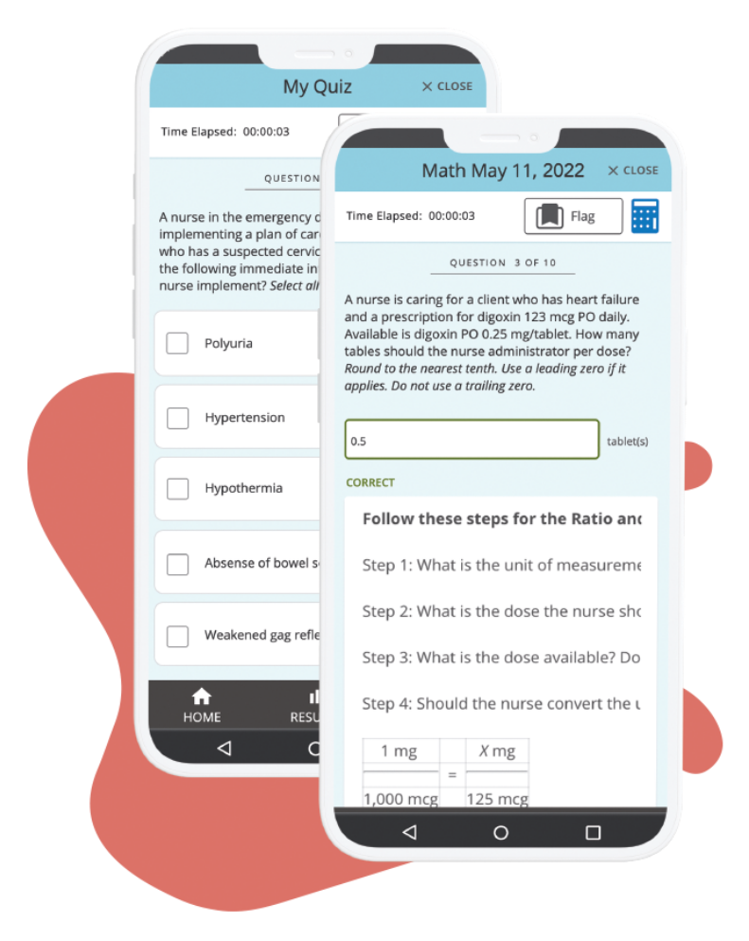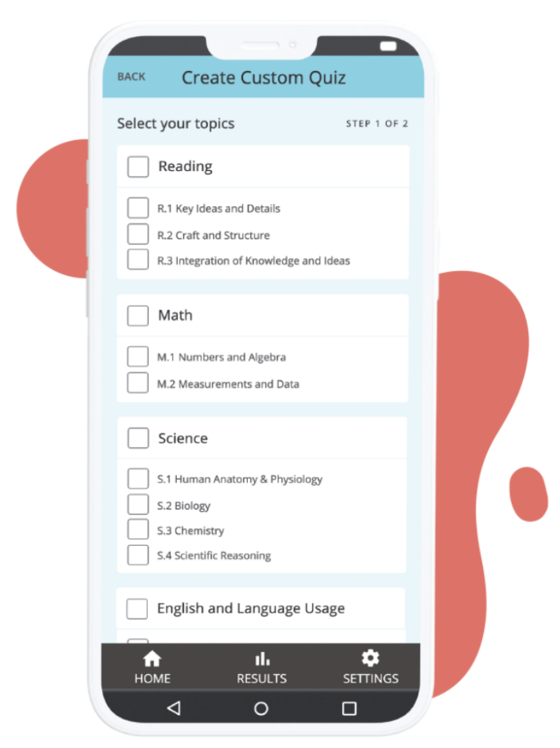

**Introducing the Official ATI TEAS Prep App!**

With the app, you will have the ability to study for the ATI TEAS anywhere, anytime. The app offers these benefits:

* More than 2,400+ practice questions
* Question of the Day
* Custom quiz creator
* Study mode and exam mode quizzes
* Answer rationales in study mode
* Progress dashboard
* And more!

**SCAN THE QR CODE FOR MORE INFO!**